**KAMPALA URBAN SCHOOLS**

**BEGINNING OF FEBRUARY EXAMINATIONS, 2024**

**PRIMARY FIVE SOCIAL STUDIES**

**NAME:_________________________________________STREAM: _______**

**SECTION A**

1. Write SST in full.

___ ___________________________________________________________________

2. Why is a compass important to a pilot?

________________________________________________________________________

3. Name the example of the road sign below?

_____________________________________________________________________

4. Mention the bird that is found in the middle of Uganda flag.

_______________________________________________________________________

5. Give one example of Tribe that belongs to the Bantu.

_________________________________________________________________________

6. Write UNEB in full.

___________________________________________________________________

7. How are farmers useful to the people in Kampala?

___________________________________________________________________

8. In which division of Kampala is Mulago Hospital located?

___________________________________________________________________

9. Name one type of road in your district.

___________________________________________________________________

10. Identify one means of communication commonly used in your district.

___________________________________________________________________

11. Give one cultural activity practiced by people in your community.

___________________________________________________________________

12. What do we call people who walk on the road?

___________________________________________________________________

13. Draw and name the weather condition good for planting crops by farmers.

|  |
| --- |
|  |

14. Give the name given to the type of vegetation created by God.

_________________________________________________________________________

15. What name is given to a home and all its surrounding?

___________________________________________________________________

16. Who is believed to be the first Muganda according to the Baganda?

____________________________________________________________________

17. State one way Meat can be preserved at home.

___________________________________________________________________

18. What title is given to the head of state in Uganda?

___________________________________________________________________

19. How important is an airport to the people in your district?

___________________________________________________________________

20. Identify one way the police keeps law and order.

___________________________________________________________________

21. Name the raw material needed to produce clothes.

___________________________________________________________________

24. Write one example of a hospital built by missionaries.

___________________________________________________________________

23. Why do the children in the picture below learn from that kind of school?

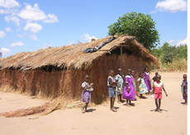

________________________________________________________________________

24. Name the basic need got from rivers ,lakes and rainfall.

___________________________________________________________________

25. What do we call the first help given to an accident victim before taken to hospital?

___________________________________________________________________

26. Give the common type of education people in your district receive.

___________________________________________________________________

27. What title is given to the king of Tooro Kingdom?

___________________________________________________________________

28. In which way is too much rainfall dangerous to people?

___________________________________________________________________

29. How is the Mayor of Kampala chosen to be a leader?

___________________________________________________________________

30. Name the social activity on which the items below are used by people in your community.

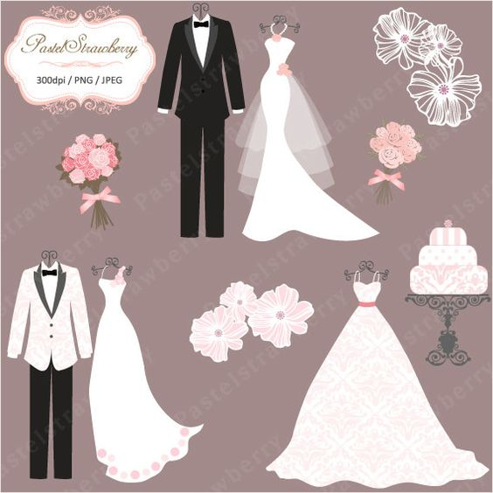

___________________________________________________________________

31. Give one group of animals found in a game park.

__________________________________________________________________

32. Mention any one means of transport used in water transport.

___________________________________________________________________

33. Suggest one way of keeping our school clean.

___________________________________________________________________

34. Write down the name of the police station near your school.

___________________________________________________________________

35. Name the example of a house used by scouts and girl guides in a camp.

__________________________________________________________________

**For questions 36 – 40, answer Either Christianity Or Islam but not both.**

36. **Either:** What are Christians reminded of on Christmas?

___________________________________________________________________

**Or:** Give one pillar of Islam about the poor.

___________________________________________________________________

37. **Either:** Where did Adam and Eve live?

___________________________________________________________________

**Or:** Where was Surat Al-Humaza revealed?

___________________________________________________________________

38. **Either:** Write down the Prince of Peace according to Christianity.

___________________________________________________________________

**Or:**  Name the first prophet in Islam.

___________________________________________________________________

39. **Either:** Who is believed to be the father of all believers?

___________________________________________________________________

**Or:** Where do worshipers face during prayers in a mosque?

___________________________________________________________________

40. **Either:** In Which book of the bible do we find the story of the Israelites leaving Egypt?

___________________________________________________________________

**Or:** On which day of the week are Juma prayers said in Islam?

___________________________________________________________________

**SECTION B**

41. (a) Write down the types of road signs.

i)_________________________________________________________________

ii)_________________________________________________________________

iii)_________________________________________________________________

iv)_________________________________________________________________

42. (a) What is a tribe?

______________________________________________________________________

(b) Write down any two examples of ethnic groups found in your district.

i) __________________________________________________________________

ii) _________________________________________________________________

(c) Mention the economic occupation of the Bahima tribe in Uganda.

____________________________________________________________________

43.(a) Give two elements of a good map.

i)___________________________________________________________________

ii) __________________________________________________________________

(c) Draw the map symbol of the following.

|  |  |
| --- | --- |
|  |  |
| A railway line | A swamp |

44(a) What are stories of long ago known as?

____________________________________________________________________

(b) Write any three tasks that Gulu gave Kintu before he married Nambi.

i)___________________________________________________________________

ii)___________________________________________________________________

iii____________________________________________________________________

45.a) Use the graph below to answer the questions that follow.

a) Which kingdom in the graph is located in central Uganda?

__________________________________________________________________________

b) Name the kingdom with many people in the graph above.

__________________________________________________________________________

c) Name any two kingdoms in the graph above located in western Uganda.

i)_________________________________b)______________________________________

46. (a) Give two examples of valleys found in Kampala.

i)_________________________________ii)_______________________________

(b)Write down any two common means of communication used in Kampala. i)___________________________________________________________________

ii)__________________________________________________________________

47. (a)What is population?

__________________________________________________________________________________________________________________________________________

b) Give one cause of a high population in an area.

_______________________________________________________________________

c) Identify any two districts in Uganda with a high population.

i._____________________________________________________________________

ii._____________________________________________________________________

48.a) Who are voluntary leaders?

___________________________________________________________________

b) Write down three examples of voluntary organizations.

i)_________________________________________________________________

ii)__________________________________________________________________

iii)__________________________________________________________________

49. (a) What is the meaning of the word transport?

________________________________________________________________________

b) Give any three types of transport commonly used in Kampala.

i)_______________________________(ii)___________________________________

iii)______________________________iv)___________________________________

50.a) Write any two examples of hills in Kampala

i) ___________________________ii)____________________________________

(b) Give any two importances of hills to the people in Kampala

(i) _________________________________________________________________

(ii) ______________________________________________________________

**For questions 51 – 55, answer Either Christianity Or Islam but not both. No marks shall be awarded to whoever answers both Islam and Christianity.**

51. **Either:** (a)What was God’s last creation? __________________________________________________________________

(b) Identify any other three creations of God.

i)__________________________________________________________________

i) _________________________________________________________________

iii) _________________________________________________________________

**OR:** a)Name the two types of people who are allowed to fast during the month of Ramadhan.

(i)____________________________ii)_________________________________

b) Why is zakat an important practice in Islam?

i)____________________________________ii)_________________________

52 **Either :(a)** Give four ways Jesus used to show care for his people.

i)____________________________ii)______________________________

iii)___________________________iv)______________________________

**OR:**Write down four ways how Muslims are different from Christians.

i)_________________________________________________________________

ii)________________________________________________________________

iii)________________________________________________________________

iv)_________________________________________________________________

53. **Either:**(a) Which apostle :

i) Betrayed Jesus_______________________________________________

ii)Denied Jesus__________________________________________________

iii)Was also Known as Rock________________________________________

iv)Doubted Jesus’ resurrection______________________________________

**Or:** (a) What is the purpose of Zakat.

i.__________________________________________________________________

b)Mention the two types of people that should benefit from Zakat.

i)__________________________________ii)_____________________________

(c) Why are muslims encouraged to fast?

______________________________________________________________________

54. **Either:** (a)Who baptized Jesus?

___________________________________________________________________

(b) In which River was Jesus Baptised?

_____________________________________________________________________

c) List down any two important days observed by Christians as important.

i)______________________________ii)___________________________________

**Or:** (a) Where did prophet Muhammad (PBUH) begin his journey?

___________________________________________________________________

(b) Why did the prophet flee Mecca to Medina?

___________________________________________________________________

(c) What is a jihad?

___________________________________________________________________

(d) On which day do Moslems congregate?

___________________________________________________________________

55. **For both:**Write any four things you can do to promote peace in community.

i) __________________________________________________________________

ii) _________________________________________________________________

iii) ________________________________________________________________

iv._________________________________________________________________